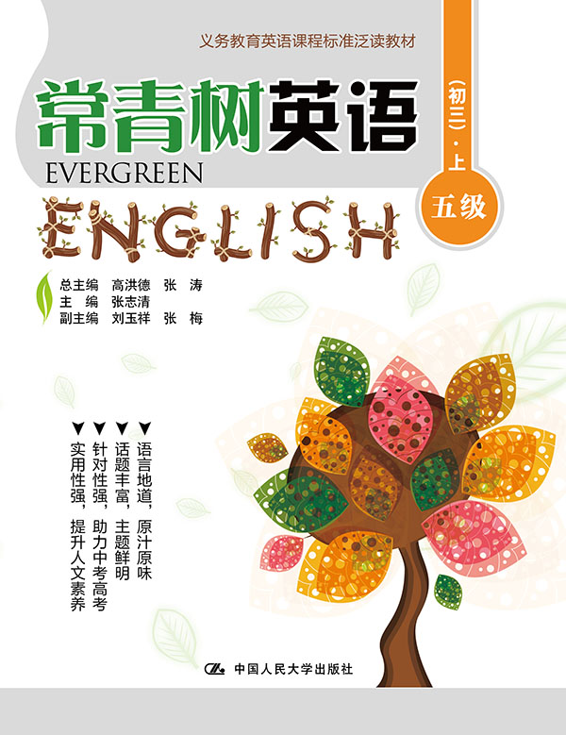
书名：常青树英语 五级（初三）·上
书号：978-7-300-21849-6
作者：高洪德 张涛 张志清
责任编辑：鞠方安
成品：177*228 页数：187
纸张：70克高白胶
装祯：平装
出版时间：2015年9月
定价：35.00元
出版社：中国人民大学出版社

- 本书卖点
- 语言地道、原汁原味
- 话题丰富、主题鲜明
- 针对性强、助力中考高考
- 实用性强、提升人文素养

◆ 读者定位
初中生

- 作者简介
高洪德，山东省教学研究室英语教研员、特级教师，中国教育学会外语教学专业委员会副理事长、山东省教育学会外语教学研究专业委员会理事长。
张涛，山东省教育学会外语教学研究专业委员会秘书长、山东省教学研究室英语教研员。

- 内容简介
《常青树英语 五级（初三）·上》的编写遵循了《义务教育英语课程标准》的要求，符合中国英语教学实际，难度上契合我国初中（三年级）学生的英语学习现状。全册以课程标准24个话题为主线，材料的选取与现行教材的话题相匹配。五级上册每篇控制在150~400词，设置了47篇文章。每篇文章前面都有阅读导语，以引起学生的阅读兴趣，并配有生动有趣的插图。课后配有多样化的学习任务。

◆ 简要目录
Lesson 1 Tips for a New School Year Start
Lesson 2 New Year’s Resolution
Lesson 3 How to Manage Your Time
Lesson 4 I Like Travel
Lesson 5 My Stay in Thailand
Lesson 6 Traveling with the Pet Rabbit
Lesson 7 Mom Calls the Shots on Son’s iPhone
Lesson 8 The Selfie Bug
Lesson 9 An Experiment
Lesson 10 Communication Between Parents and Teenagers
Lesson 11 Let’s Climb Popo
Lesson 12 How to Handle Problems at School
Lesson 13 A Lovely Girl
Lesson 14 A Friend
Lesson 15 Teen Cliques
Lesson 16 A Friend in Need
Lesson 17 Friend Problems: If You Have a Friend in Need
Lesson 18 Make It Come True
Lesson 29 Follow Your Dream
Lesson 20 Risking
Lesson 21 The Law of Life Grandma Taught Me
Lesson 22 Never Underestimate Your Power
Lesson 23 Keep Your Goals in Sight
Lesson 24 A Simple Gesture
Lesson 25 Is It OK to Carry a Backpack on Just One Shoulder?
Lesson 26 “What’s the Right Weight for My Height?”
Lesson 27 Cigarette Smoking
Lesson 28 Do You Get Enough Sleep?
Lesson 29 Chinese Tea
Lesson 30 Colorful Rice
Lesson 31 How to Follow Italian Table Manners
Lesson 32 Happiness Doesn’t Need a List
Lesson 33 “Eat-up” Campaign on Campus
Lesson 34 Working Christmas Day
Lesson 35 New Rules and Behavior Standards for Middle School Students
Lesson 36 A Boy and His Tree
Lesson 37 If the Dream Is Big Enough
Lesson 38 The Old Man and His Donkey
Lesson 39 What to Do If You’re Caught in a Storm
Lesson 40 Rainy Britain
Lesson 41 The Story of the Morning-glory Seed
Lesson 42 I Wandered Lonely as a Cloud
Lesson 43 O Captain! My Captain!
Lesson 44 Where Will We Go from Here?
Lesson 45 From the Horseless Carriage to the Intelligent Car
Lesson 46 Communicating in the Information Age
Lesson 47 What’s Up with the Weather?
Keys

◆ 上架建议
中学英语泛读读本

书摘
Lesson 1 Tips for a New School Year Start
Guidance
How to beat the stress and organize your study environment? 新的学期已经来临，有的同学满怀信心，有的同学却忧心忡忡。亲爱的同学们，面对新的压力和挑战，你们准备好了吗？或许你会从下面的建议中获取灵感呢！

The summer holiday is over. Some students are thirsty for knowing their new teacher and meeting their friends to share their summer adventures, and while others are more worried about the new year. Here are some tips to help you beat the stress and organize your study environment.
Reconnecting with a healthy lifestyle
During holidays, children have often been allowed to sleep late and eat a little of what they wanted at any time. The first thing to do is to help yourself make a smooth start and not to wait until the last day to find a healthy lifestyle. You should get used to having regular and reasonable hours of sleep and eating healthy food. This of course needs several days of “rehabilitation.” The ideal thing is to start reconnecting with a healthy lifestyle one week to ten days before school starts.
Create a pleasant study environment
A few days before school starts, do a tidy-up of the desk and the shelves. Sort and throw away the relics of the past year. Donate your old books, pens and school things if they are still usable. Clean up your desk. Make it a comfortable place to do your homework. Your workplace should be a quiet well-lit corner where it feels good.
Talk over with your parents
If you feel anxious of the new school year, it is very important to talk to your parents about your fears. They will surely find a way to help you get over your fears and gain confidence. They will certainly show you that they believe in your abilities, and will be willing to help you with your first pieces of homework if need be.
Beat stress
If you are overly anxious about performance, work through your negative beliefs, especially the beliefs about the implications of school failure. Good performance will be achieved only when you beat your fears and discover your own personal worth.
Set goals
Enjoy setting goals for yourself, so you can get over your weaknesses and reach your full potential. Your study goals must be realistic and achievable. For example, start with small steps to reach higher targets.
Motivation
Achieving some goals will certainly motivate you to reach more challenging targets. Another motivating factor would be to understand that you work mainly for yourself and your future career. You must understand that studying well is your chance for self-development.

